ASSIGNMENT- TeamCompetishun

NAME: Nampally Sai Kiran Varma

ROLL: 20bsm035

INSTITUTE: PDPM IIITDMJ  
ROLE: React JS Developer  
  
**github:** <https://github.com/VARMAMASTER/List-it>

**Instructions to download and run the application:**

1. Download from git hub - [GitHub](https://github.com/VARMAMASTER/List-it)
2. Install the libraries of react mentioned in the package.json on to your machine (or) open file in vsCode simple run “ npm i” to install all the dependencies  
    react: ^18.2.0,

react-Axios: ^2.0.6,

react-dom: ^18.2.0,

react-router: ^6.18.0,

react-router-dom: ^6.18.0,

1. Then run “npm start” to run development server.

**APP Screen Shots:**

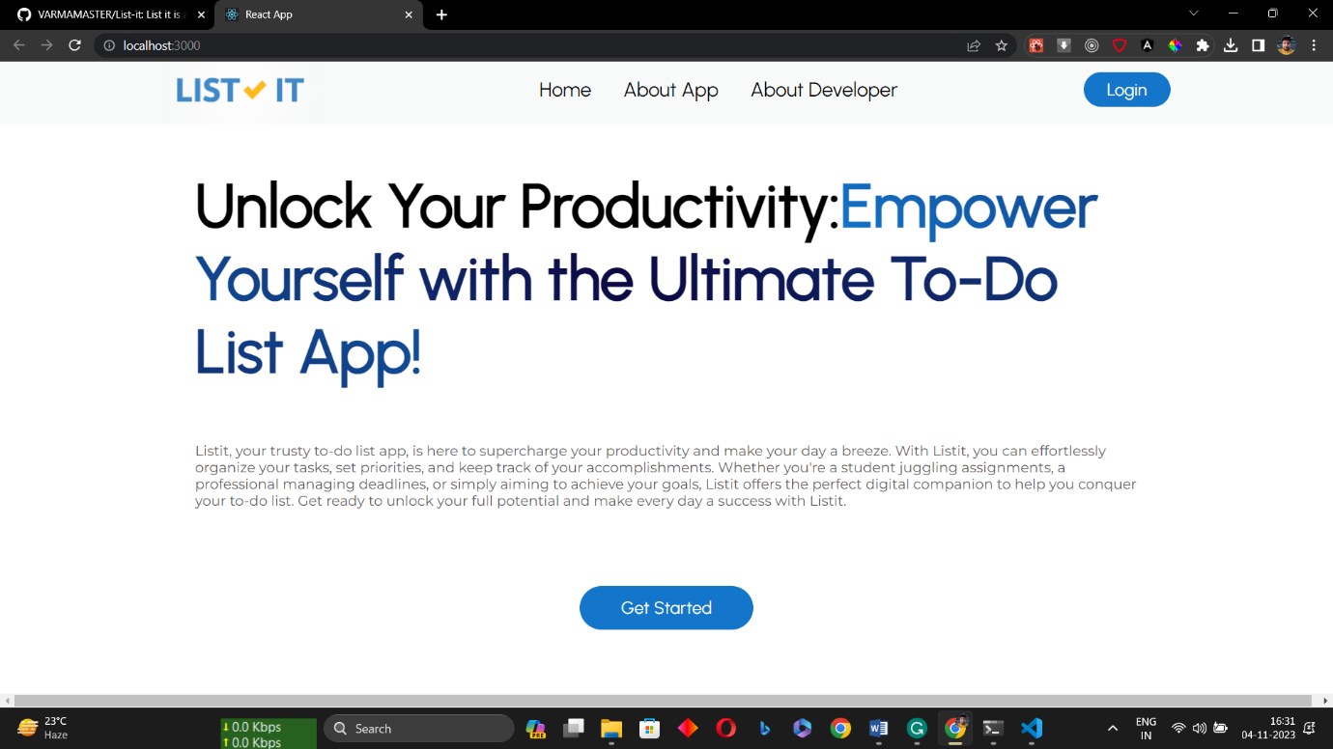

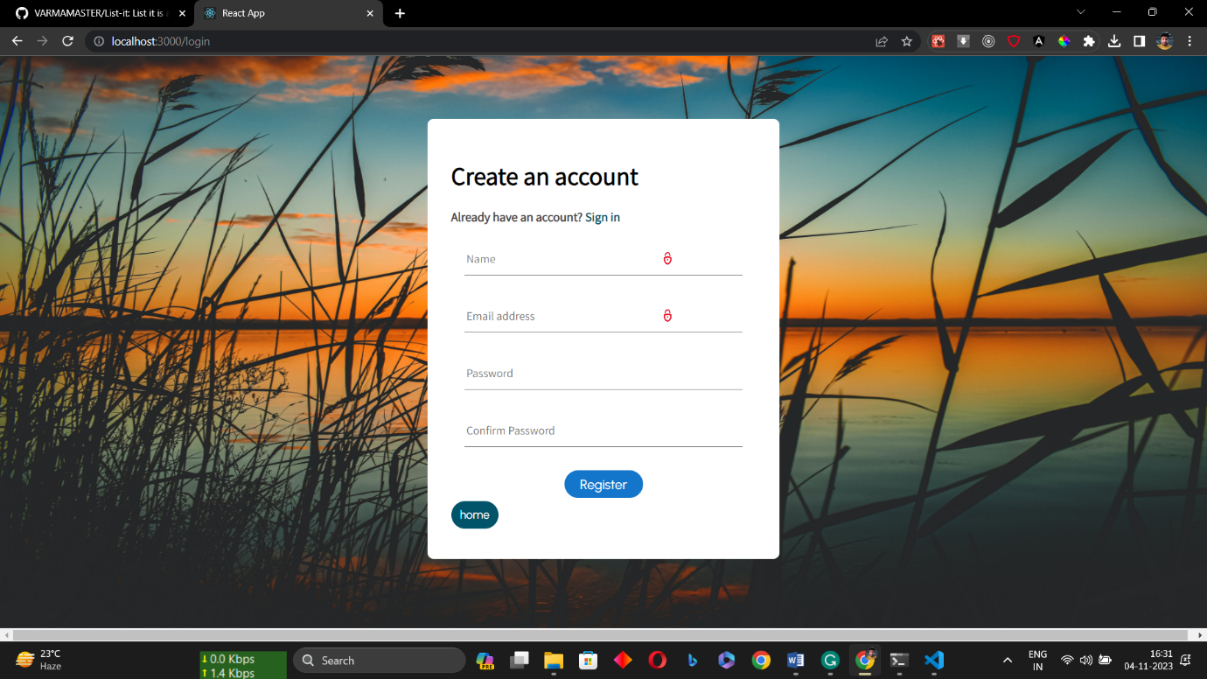

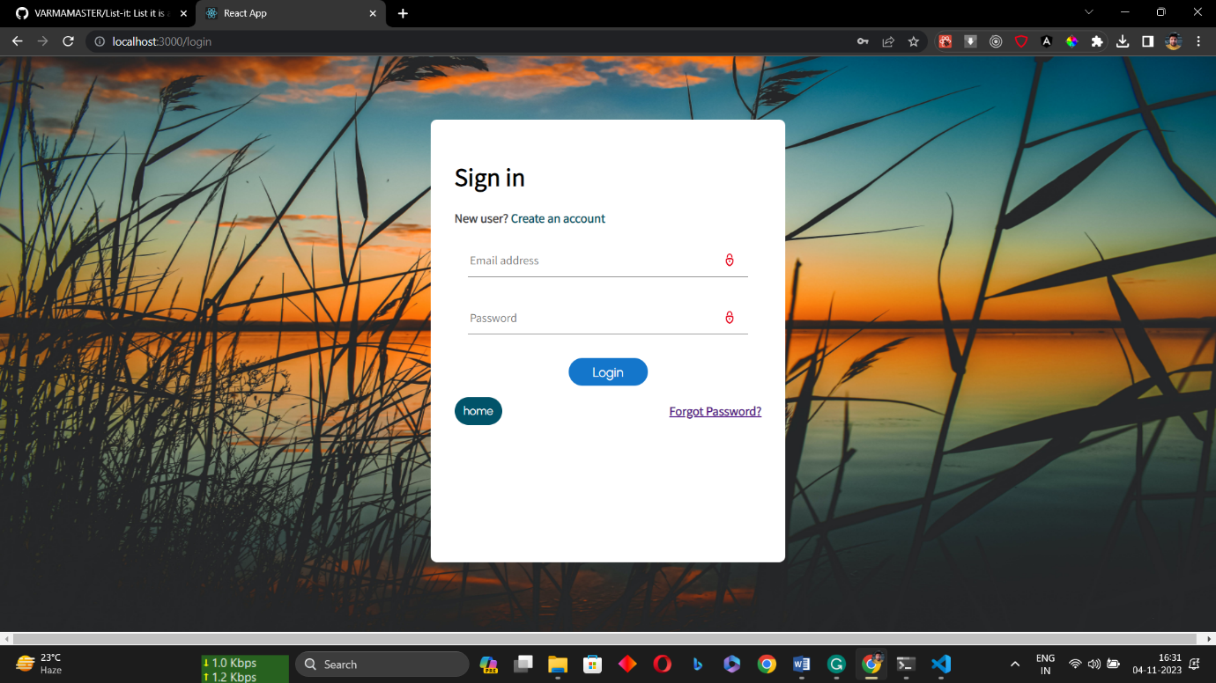

**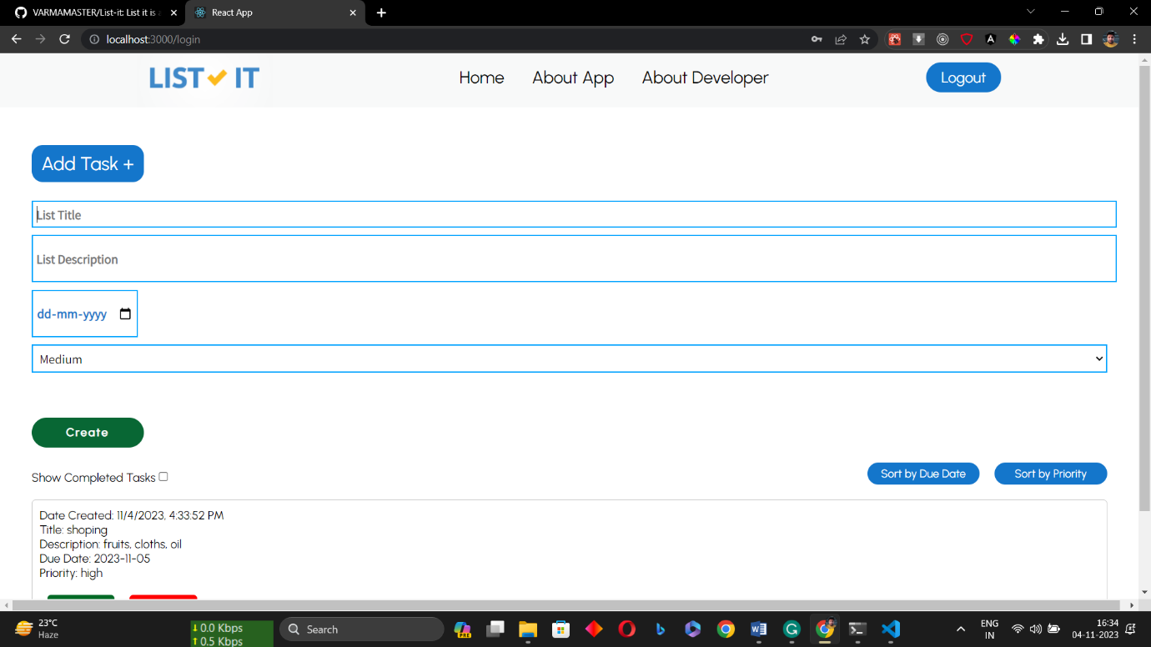  
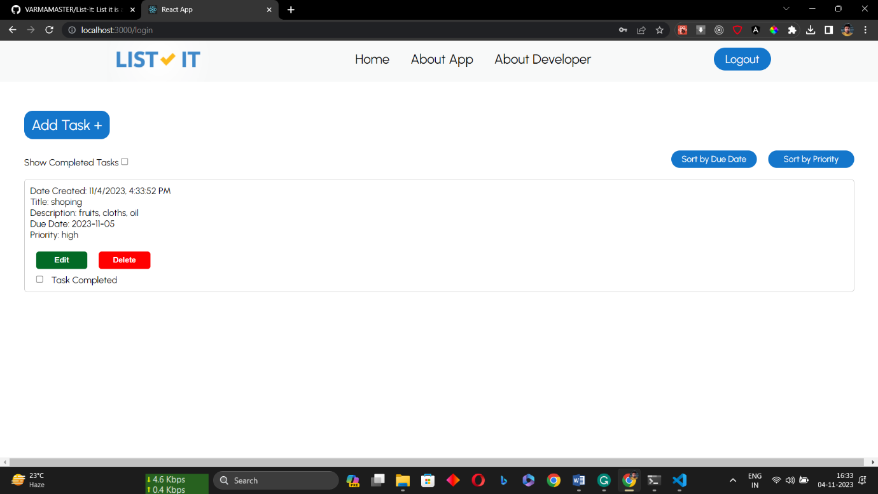**

**Implemented Features:**

1. User Authentication
2. Authentication State
3. Task Management
4. Logout button
5. Intuitive user interface Interface
6. Error Handling

**Bonus Features – Implemented All the Bonus Features**

1. Added due dates to tasks.
2. Implemented task prioritisation (e.g., high, medium, low).
3. Filtering and Sorting .

**For more details like authentication flow and security messures please read, Readme file in** [**github**](https://github.com/VARMAMASTER/List-it) **.**